5.16: Use Second Law and kinematics: 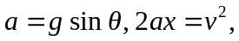 solve for . 